**Mini Project Report on**

https://lh3.googleusercontent.com/fx_NorCOYaeoW_uvl4KQAGjPhsLPDbYJN9I4TVy32C96PS-0ULC4ZaNqTp8XgD0VbPWM4vwpwA3C7_noPxcs5ucWuOW_VI4uq-DrerHXel1fLiWnMKpXvKsyg5lhM_g0X7h731bsPi1Qs87wmnAeag

**PLANT DISEASE DETECTION USING MACHINE LEARNING**  
https://lh3.googleusercontent.com/fx_NorCOYaeoW_uvl4KQAGjPhsLPDbYJN9I4TVy32C96PS-0ULC4ZaNqTp8XgD0VbPWM4vwpwA3C7_noPxcs5ucWuOW_VI4uq-DrerHXel1fLiWnMKpXvKsyg5lhM_g0X7h731bsPi1Qs87wmnAeag

**Submitted in partial fulfillment of the requirement for the award of the degree of**

**BACHELOR OF TECHNOLOGY**

**IN**

**COMPUTER SCIENCE & ENGINEERING**

**Submitted by:**

**Student Name**             **UniversityRoll No.**

**Monika kumari nath               2016856**

***Under the Mentorship of***

**Ms.Garima Sharma**

**Designation**



**Department of Computer Science and EngineeringGraphic Era (Deemed to be University)**

**Dehradun, Uttarakhand**

**July-2023**



**CANDIDATE’S DECLARATION**

I hereby certify that the work which is being presented in the project report entitled **“Plant disease detection using machine learning ”** in partial fulfillment of the requirements for the award of the Degree of Bachelor of Technology in Computer Science and Engineeringof the Graphic Era (Deemed to be University), Dehradun shall be carried out by the under the mentorship of **Ms.Garima Sharma, Designation**, Department of Computer Science and Engineering, Graphic Era (Deemed to be University), Dehradun.

Name                                                                           University Roll no

 Monika kumari nath                                                                      2016856

**Table of Contents**

|  |  |  |
| --- | --- | --- |
| **Chapter No.** | **Description** | **Page No.** |
| Chapter 1 | Introduction | **1-3** |
| Chapter 2 | Literature Survey | **4-6** |
| Chapter 3 | Methodology | **7-10** |
| Chapter 4 | Result and Discussion | **10-11** |
| Chapter 5 | Conclusion and Future Work | **11-12** |
|  | References |  |

**Chapter 1**

**Introduction**

In the following sections, a brief introduction and the problem statement for the work has been included.

1. **Introduction**

[1] Approximately 70% of India's population relies on agriculture, highlighting the importance of identifying plant diseases to minimize yield losses. Manual observation of these diseases presents significant challenges and requires extensive expertise and time. To address this, the utilization of image processing and machine learning models is advantageous for detecting plant diseases.This project thoroughly analyzes various image parameters and features to achieve optimal accuracy in identifying different diseases affecting plant leaves. In the past, plant disease detection heavily relied on visual inspection by experts or involved chemical processes. However, these methods necessitate a large team of experts and continuous monitoring, making them costly, particularly for large farms.[3] In such scenarios, the proposed system proves invaluable for monitoring extensive crop fields.

 The automatic detection of diseases based on leaf symptoms simplifies the process and reduces expenses. Compared to other deep learning-based approaches, the proposed solution for plant disease detection is computationally efficient and provides faster predictions. It leverages statistical machine learning algorithms and image processing technique.

This technique helps in most of the cases for farmers to detect early blight and late blight detection of plant ,which thus makes it easier for farmers to find out which plant is healthy or not and which plant can cause more disease to other plants as well , this helps for future detection and removal of plants which might through the symptoms of disease being predicted.

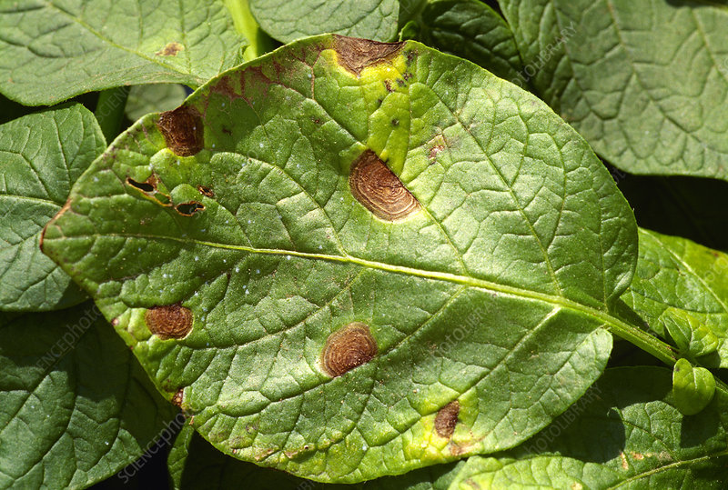

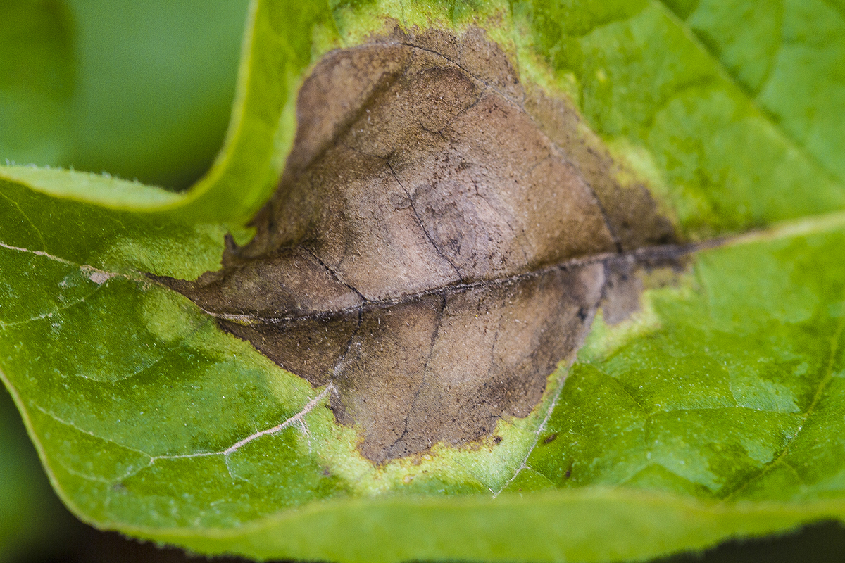

**Figure 1.1 Early blight and Late blight**

There are a lot of significant crops exist in India, one among them is Potato. More than three-fourths of the population of India consumes potato daily at the same time it is one of the popular yielding crops in India. Yet, the yield of the potato crop can be diminished due to various diseases such as late blight and early blight. These diseases are also known as Phytophthora Infestans and Alternaria Solani respectively in scientific terms. Timely identification and classification of these diseases will lead to avoid the yield as well as financial losses.

 The popular way of identification of these diseases through the utilization of the human eye for decades. But, this methodology arises with certain infeasibilities such as overtime will be taken for processing and shortage of experts at fields in remote locations. Therefore, the image analysis turned out to be an efficient methodology that will play a vital role in monitoring as well as the identification of the plant disease conditions effectively. Because the visible patterns are available on the plant leaves and patterns will be identified using various image processing methodologies for obtaining a particular pattern corresponding to a disease which will create an impact in the identification of various diseases. Thus the obtained features or patterns will be compared with the historical data and able to classify the disease which can be done by using various machine learning methodologies. So, the combination of image processing and machine learning is very effective in the identification and classification of diseases.

**Chapter 2**

**Literature Survey**

In this chapter some of the major existing work in these areas has been reviewed. This has been an automated system that categorizes potato plant diseases as well as unaffected leaves from the public image, known as ‘Plant Village’. The mentioned segmentation process and classification process through support vector machine methodology displays classification of images about 300 and the accuracy of the proposed model about 95%. Thus, the proposed approach offers a way for the automatic diagnosis of plant diseases on a huge scale. [4] The image segmentation is used for designing a system that is automated and easy to use. For primary diseases in potatoes such as Late Blight and Early Blight, a little computational effort is identified. The approach would provide farmers with reliable, and successful methodology and time-saving processes for disease identification.

[2][4][5] The detection and classification of diseases in various plants will be followed with various phases such as data acquisition in the form of images, pre-processing of the obtained images using image processing methodologies, image segmentation for the identification of the region of interest, extraction of features, and finally, depending on the obtained patterns classifying the images. The methodologies are mainly discussed based on machine learning and image processing methodologies as the proposed framework is also based on those methodologies only.

[5][1][2]This includes the image data collection scale, no groups, preprocessing, technological segmentation, styles, classifier accuracy, etc.[5] It also utilized the survey for further research and upgraded the detection and classification of various diseases related to potato plants.

K.Muthukannan and colleagues discovered spot infections in leaves and categorized them according to the diseased leaf categories using various machine learning algorithms. LVQ - Learning Vector Quantization, FFNN - Feed Forward Neural Network, and RBFN - Radial Basis Function Networks were utilized to diagnose diseased plant leaves by analyzing the collection of form and texture data from the afflicted leaf picture. The simulation showed that the proposed system is effective. With the support of this work, a machine learning-based system for improving crop quality in the Indian economy can be developed. [1]

CNN and Modeling Adversarial Networks were used to classify plant diseases. Others, like Emanuel Cortes A deep neural network and semi-supervised algorithms were trained to distinguish crop species and disease status of 57 different classes using a publicly available dataset of 86,147 photos of ill and healthy plants. rs-net was the unlabeled data experiment that functioned successfully. With a detection rate of 1e-5, it was able to score more than 80% in the training phase in less than 5 epochs.[5]

Srdjan Sladojevic and colleagues present Deep Convolutional Neural Network Supported Identification of Crop Diseases by Plant Image Classification, a new method for the construction of a crop disease recognition model based on plant image classification and deep convolutional networks. The methodology employed and the novel technique of training allow for a quick and painless system set up in practice. With the ability to identify crops from their surroundings, the built model can recognize thirteen types of plant illnesses from healthy leaves. All of the necessary processes for applying this disease recognition model are detailed throughout the study, beginning with the collection of photographs in order to establish a database that is evaluated by agricultural experts. Caffe, a deep learning framework developed by Berkeley Vision and Learning Centre, was used to perform the deep CNN training. The experimental results on the developed model achieved precision between 91% and 98%, for separate class tests, on average 96.3%.[4].

The importance of plants in the food chain dates back to ancient times. The first humans gathered wild plants for food. As settlements developed, food crops were cultivated, leading to selection of high-yielding cultivated varieties to feed the growing populations. Unlike plants, humans and other animals are unable to manufacture their own food. Therefore, they are dependent, directly or indirectly, on plants. Plants are found in natural ecosystems such as rain forests, and also in agricultural areas and urbanized settings.

They are an essential part of our daily lives providing food, clean air, and important ecosystem functions. The study of plants and their function could be considered the most complex of interactions. From the time a seed germinates, it goes through a myriad of physiological processes that can be closely studied using modern tools and molecular biological methods. An open access journal such as *Plants* will give millions of readers access to that information around the world.

The convolutional neural network was used by Garima Shrestha and colleagues to identify plant disease in 2020. With an accuracy of 88.80 percent, the authors were able to classify 12 plant diseases. Experimentation was carried out by using a collection of 3000 high-resolution RGB photographs [6]

**Chapter 3**

**Methodology**

Methodology helps us in gaining information about the project being worked on and in this project I have used some methods and functions which helped me in finding the symptoms of diseases in plants which may be further helpful for providing a better understanding of plants in future and to detect the type of disease being displayed there. Firstly ,we classify the plants based on their types whether they are healthy or not and then we extract the features from it.

**Dataset:**

The collected data from an openly accessible database consists of some of the

healthy images about 54,306 from the total crop species about 14. From that particular database, potato species-related data was considered to  implement the proposed framework. The obtained dataset consists of 300 potato plant leaves which were categorized as follows. In the project there have been a use of only two types of plant :

1. The plant having disease is called Early blight.
2. The plant having disease is called Late Blight

 What is Early Blight?

Early Blight is primarily a disease of stressed or senescing plants. Symptoms appear first on the oldest foliage. Affected leaves develop circular to angular dark brown lesions  0.12 to 0.16 inch (3–4 mm) in diameter. Concentric rings often form in lesions to produce characteristic target-board effect.

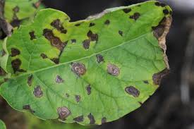**Fig 2.1 The stage of early blight**

This is the starting symptoms of early blight caused in a potato plant [4].

The major phases of the detection of diseases from the plant leaves are image segmentation, feature extraction, and classification.

What is late blight?

Late blight of potato is identified by blackish/brown lesions on leaves and stems.When plants have become infected,

lesions (round or irregularly shaped areas that range in color from dark green to purplish black and resemble frost injury) appear on the leaves, petioles, and stems. A whitish growth of spore-producing structures may appear at the margin of the lesions on the underleaf surfaces. Potato tubers develop rot up to 15 mm (0.6 inch) deep. Secondary fungi and bacteria (particularly Erwinia species) often invade potato tubers and produce rotting that results in great losses during storage, transit, and marketing.

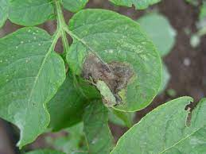 **Fig 2.2 The stage of late blight**

**IMAGE SEGMENTATION:**

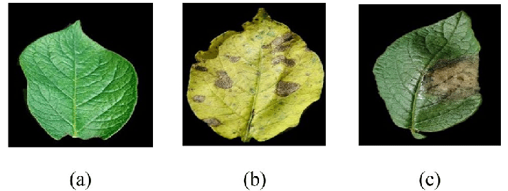

**Figure 3.1 This figure shows (a)Healthy plant   (b)Early blight  (c) Late blight**

**In different stages of finding a blight there has been a process and methods used by CNN where different layers are used for processing of an image used in detection of plant disease. Different layers include**

1. **Input layer :** Theinput plant
2. **convolutional layer :** Convolutional layer: produces an activation map by scanning the pictures several pixels at a time using a filter
3. **Pooling layer:** Pooling layer: reduces the amount of data created by the convolutional layer so that it is stored more efficiently**.**
4. **Relu :**This layer shows that, for certain values of the input to a neuron, that neuron's output would negatively contribute to the output of the neural network.

**output layer :** The process of output image of plant

Fully connected input layer  – The preceding layers' output is "flattened" and turned into a single vector which is used as an input for the next stage.

The first fully connected layer  – adds weights to the inputs from the feature analysis to anticipate the proper label.

 Fully connected output layer  – offers the probability for each label in the end.

**PROPOSED METHODOLOGY:**

Step-1: **Image Acquisition**: It deals with the acquisition of data from reliable sources to maintain the standard and stability so that it can be compared or extended for future studies.

 Step-2: **Image Pre-processing**: It is a very essential phase of the framework. This phase mainly deals with the denoising of the image, enhancement of the image, and maintaining standard image size for all the images. Denoising and enhancement of images are essential to get a better result while segmenting the images.

Step-3: **Image Segmentation**: In this phase, the image will be segmented according to the region of interest. Here, in this case, the region of interest is the regions on the leaf which are affected by various diseases that need to be separated from the existing images.

Step-4: **Extraction of Features**: Depending on the obtained region of interest need to identify the patterns that exist. A different region of interest will have different patterns, from that scenario, one is able to extract features that are crucial in deciding the detection as well as classification.

 Step-5: **Evaluate the Affected Region**: By comparing the region of interests and extraction features, one is able to evaluate the affected regions to obtain better accuracy in the model, otherwise there exist higher deviations.

Step-6: **Processed Data**: All the information related to processed image data by using the steps-1 to      5 will be gathered into a single location.

 Step-7: **Training Data**: The training data will be obtained from the processed data. About 75% of the data with random indexing was considered to train the classifier model.

 Step-8: **Testing Data**: The testing data will also be obtained from the processed data. About 25% of the data with random indexing was considered to test the classifier model.

Step-9: **Classification:** Test data will be provided to the trained classifier to classify the images into various categories such as Late Blight, Early Blight, and Healthy.

Step-10: **Evaluation Metrics**: Depending on the obtained results from the classifier model, the evaluation metrics such as precision, recall, F1-score, and accuracy will be obtained

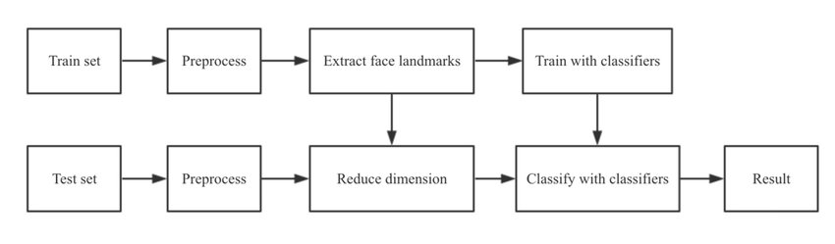

**Chapter 4**

**Result and Discussion**

The dataset considered was openly accessed standard dataset and it was divided into the training dataset. this project thus showed us that one can identify the accuracy of the Late Blight category as low when compared to the other two categories whereas the accuracy of the healthy leaves category is higher than the other two categories.Digitalization increasing across all the fields and it is high time to adopt digitalization into the field of agriculture as well to obtain better protection in terms of growth and yield. Keeping this intention as the motivation for the proposed model to detect and classify the affected and unaffected leaves of potato.

The proposed framework is able to achieve an accuracy of 80% . Yet, this accuracy needs to be improved. The existing work further can be extended by using artificial neural networks, particularly, convolutional neural networks. These days, a lot of research related to images is happening based on CNN methodologies to obtain better and reliable accuracy. The concept of activation functions, batch normalizations, convolutional layers, and fully connected layers are playing a key role in CNN architectures to attain better accuracy.

**Chapter 5**

**Conclusion and Future Work**

A deep learning model that can be used for automatic detection and classification of plant leaf diseases is created. Tomato, strawberry, soybean, raspberry, potato, corn, Pepper bell, peach, orange, grape, cherry, blueberry, apple are 13 species on which the proposed model  will be tested. 38 classes of plants were taken for identification through this work. This shows how the future of agriculture can be developed and farmers who are not much literate too can use these methods once placed in an Api for easier understanding and use of  future farmers and agriculturists . As nowadays many sensors and android application have been developed so that farmers can think of solutions in a broad way and understanding their needs and regulation is what will help this project make a good use of resources in agriculture field.

**References**

[1] S. D. Khirade and A. B. Patil, "Plant Disease Detection Using Image Processing," 2015 International Conference on Computing Communication Control and Automation, 2015, pp. 768-771, doi: 10.1109/ICCUBEA.2015.153. (Research paper)

[2] Plant Village dataset.

 https://www.kaggle.com/datasets/emmarex/plantdisease (Website)

[3What is Plant disease ?

https://www.sciencedirect.com/topics/pharmacology-toxicology-and-pharmaceuticalscience/plant-disease (Website)

[4] what is early blight?

<https://ipm.ucanr.edu/agriculture/potato/early-blight/#:~:text=Early%20blight%20is%20primarily%20a,produce%20characteristic%20target%2Dboard%20effect.(Website)>

[5][https://link.springer.com/chapter/10.1007/978-981-19-5037-7_39#:~:text=Researchers%20have%20attempted%20several%20methods,mosaic%20virus%20and%20leaf%20spot.](https://link.springer.com/chapter/10.1007/978-981-19-5037-7_39" \l ":~:text=Researchers%20have%20attempted%20several%20methods,mosaic%20virus%20and%20leaf%20spot.(Website))

[(Website)](https://link.springer.com/chapter/10.1007/978-981-19-5037-7_39#:~:text=Researchers%20have%20attempted%20several%20methods,mosaic%20virus%20and%20leaf%20spot.(Website))

[6] https://www.itm-conferences.org/articles/itmconf/pdf/2022/04/itmconf_icacc2022_03049.pdf(website)